CAFÉ THOMPSON APRON & SIGN ORDERING
Apron with the embroidered logo, rough cost is $15 each from New Chef.
New Chef Fashions
800-639-2433-any order taker
Main contact Josie ext. 241
Josie@newchef.com
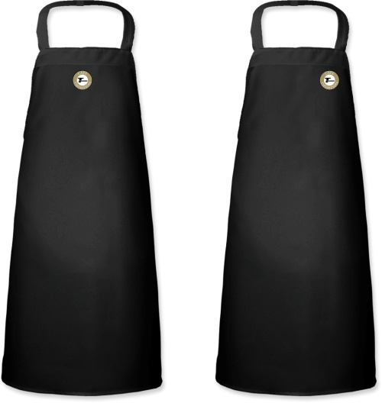
Signs will be ordered from Food Buy approved vendor; Recommendation is for framed posters.
Carl Madison
Imagery Unlimited
800-829-4018
Imagery@iuidesigns.com
11x17 poster printed on 8 mil Gloss paper roughly $12.50
20x30 pvc poster estimate under $50, receiving samples today 1/17/12

