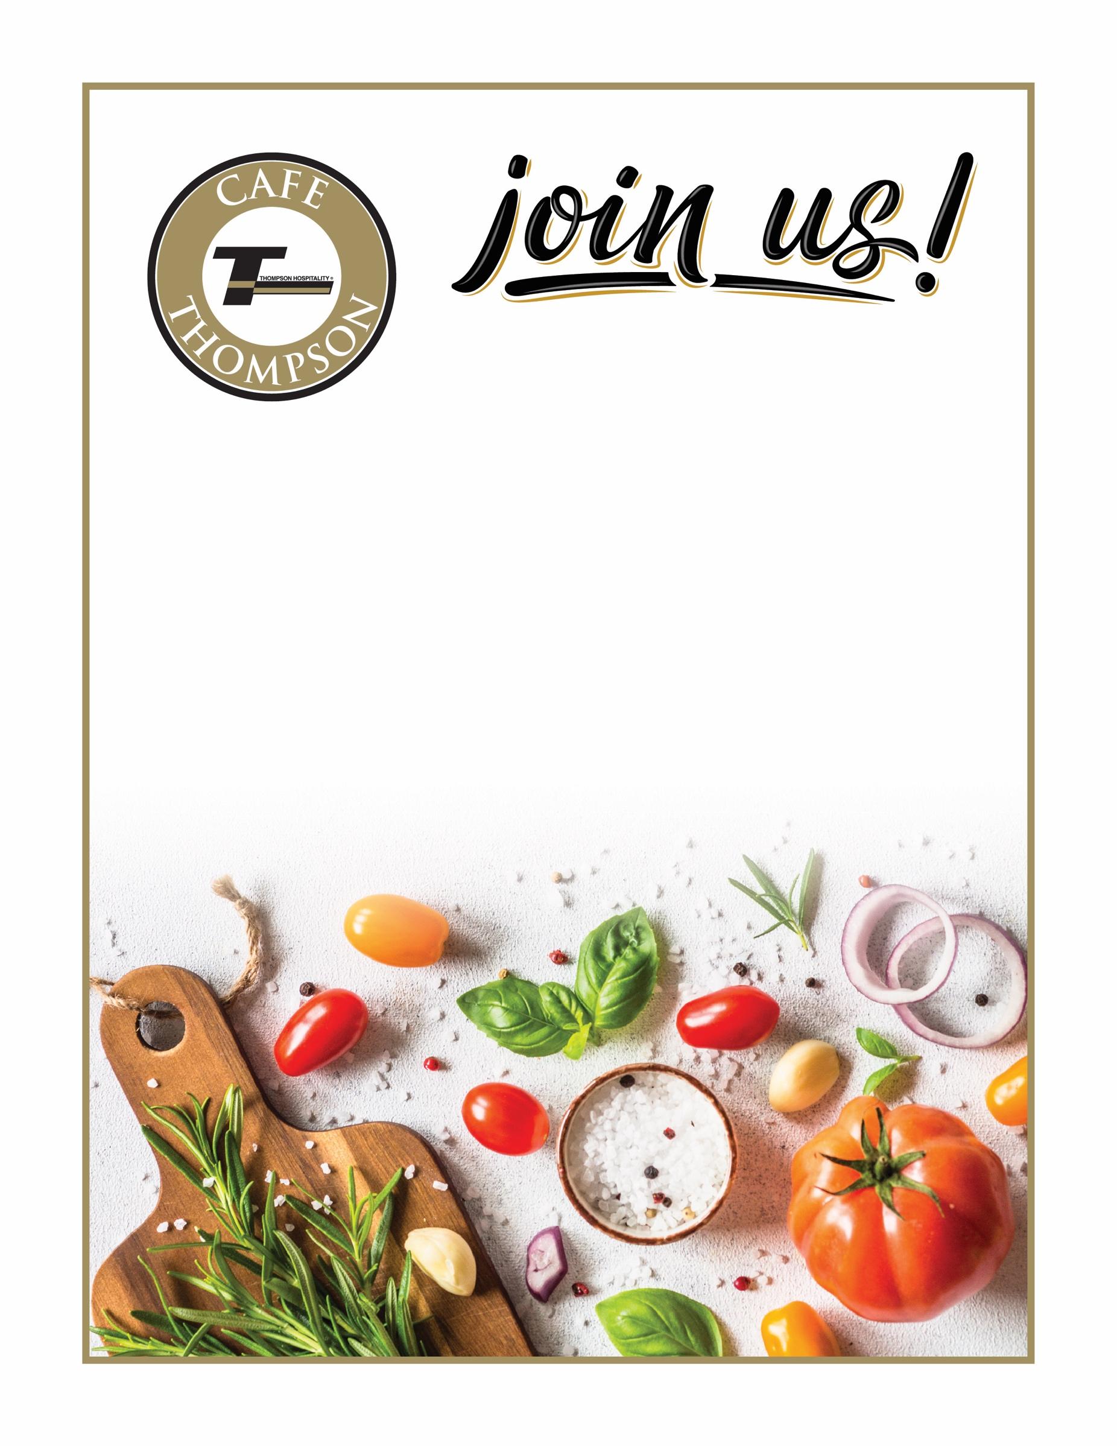
F E A T U R I N G
WEDNESDAY
JUNE 30, 2023

Selected
Menu Item

