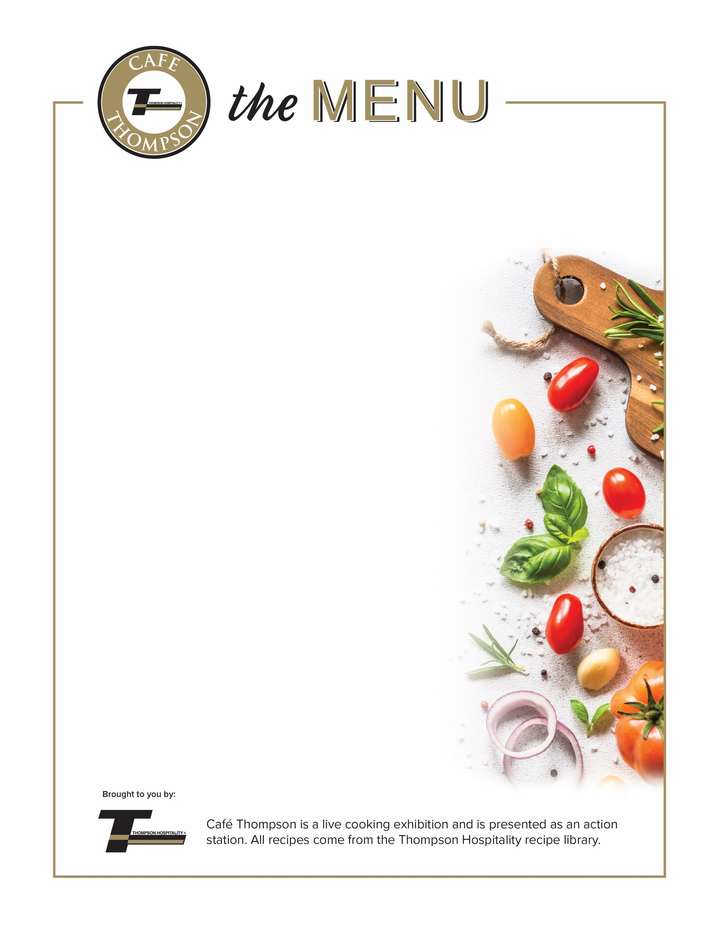
Type Event Here
Type subhead here if needed or delete.

Protein
Marinated Sirloin of Beef, Grilled to Perfection
Chorizo Argentino: Spicy Chorizo Sausage
served with Chimichurri Sauce or Pico de Gallo

Sides
Yucca Fries
Oven Roasted Rosemary Red Bliss Potatoes
Tomato & Fresh Mozzarella Salad, with Basil Balsamic Vinaigrette
Grilled Asparagus, Grain Mustard Vinaigrette
Ripe Fried Plantain, Honey
Grilled Asparagus, Grain Mustard Vinaigrette
Ripe Fried Plantain, Honey

Price $8.99

