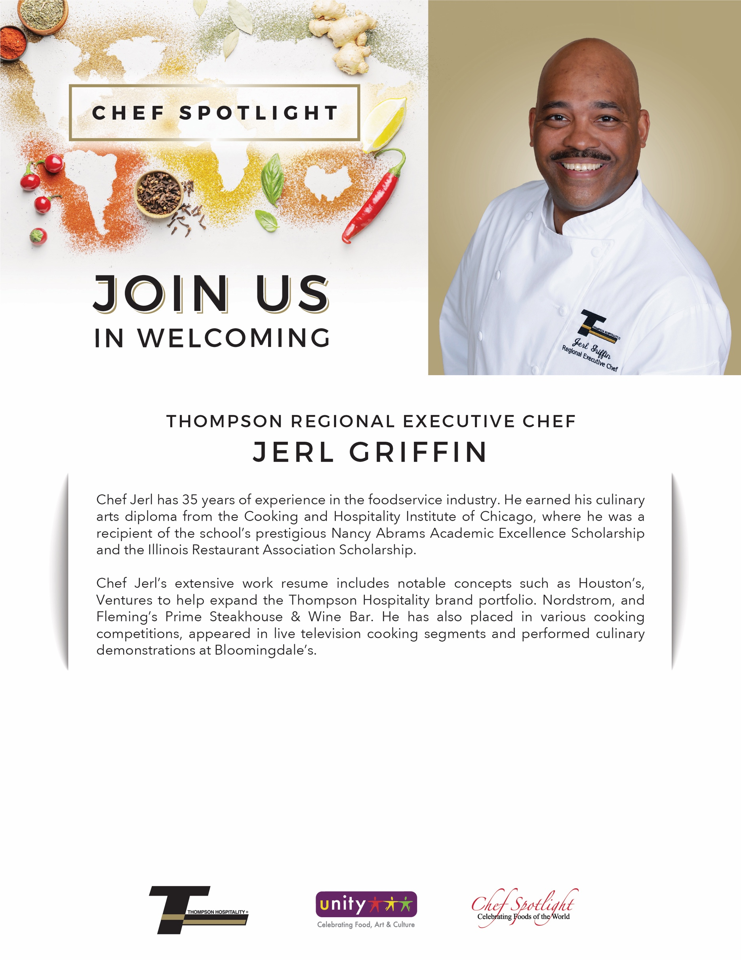

**Unit Location • Date • Location • Time**

**Herb Crusted Scallops**

served with

Stone Ground Grits, Sauteed Kale

and finished with a Creole Tomato Sauce